Unreal Game Development Documentation

SIT151 ASSIGNMENT 3

Game Name: Pixelicious

STUDENT NAME: Aya Strijakova

STUDENT NUMBER: 219066014

PRACTICAL TIME (or Cloud): 20 Hrs

Contents

Game Component & Feature 1: 3

DESCRIPTION 3

REASONING 3

BLUEPRINTS AND IMPLEMENTATION 3

Game Component & Feature 2: 4

DESCRIPTION 4

REASONING 4

BLUEPRINTS AND IMPLEMENTATION 4

Game Component & Feature 3: 5

DESCRIPTION 5

REASONING 5

BLUEPRINTS AND IMPLEMENTATION 5

Game Component & Feature 1: 6

DESCRIPTION 6

REASONING 6

BLUEPRINTS AND IMPLEMENTATION 6

Extra Transformations or Features 7

References 8

# Game Component & Feature 1:

## DESCRIPTION

The initial enemy has been replaced as candy corn, while the player ship is now a carrot, which shoots corn kernels. Pick-ups are a corn cob and toothpaste swirl.

Everything is done in 8 (scaled up by 1000%) and 16-bit (scaled up by 500%) to create dimension cohesion while maintaining the hard-edged pixel art style I’ve been practicing. An explosion animation also made it in for all collisions.

Images made used Gimp 2.1

Music and sound effects are also original and made with Beepbox ()

Font is VT323 by from Google Fonts

## REASONING

I chose to use my artistic skills to make original assets for more creative control while I changed the theme. I decided to go for a vegetable’s vs candy theme for the variety of enemies I could make later down the track. I have pixel art ready for

* spinning candy canes, shooting mint drops out the end
* Pop ‘asteroids’ that drop 3 pop rock explosives on destruction
* Gummies that take multiple hits to destroy
* A liquorice themed puzzle

It’s a versatile theme, done in pastels for a soothing experience

## BLUEPRINTS AND IMPLEMENTATION

Sprites

Player

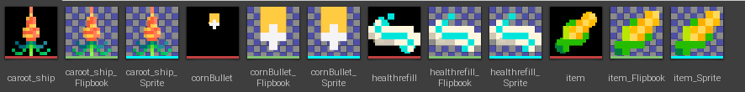

Explosion



EnemyShip

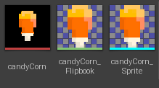

HUD

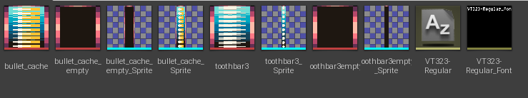

Background

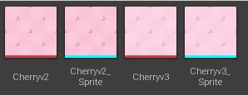

Music:

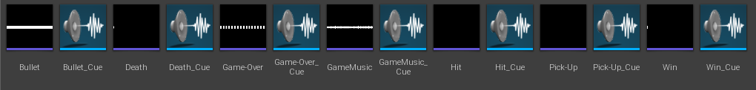

In-game Screenshot

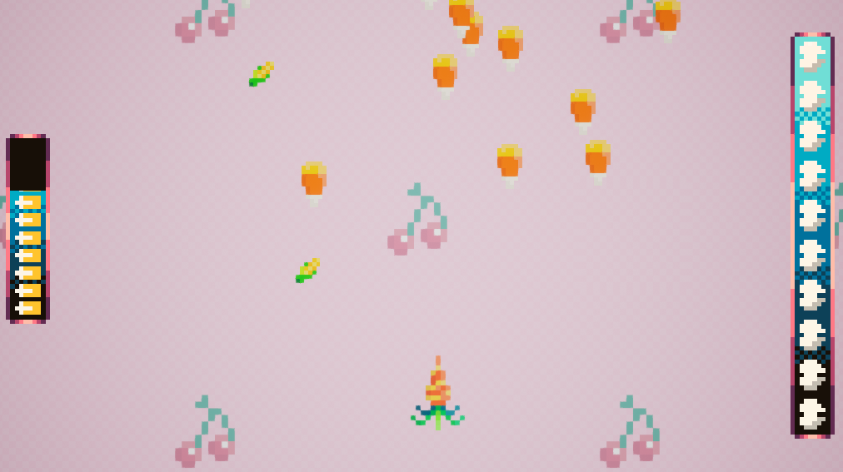

# Game Component & Feature 2:

## DESCRIPTION

The UI has also been changed to change the health bar to incorporate teeth as health points on the right side of the screen, which depletes to black as the player loses health. An ammo cache system has also been added with corn kernel reserves which also deplete to black.

## REASONING

The health bar introduced in the tutorials didn’t match up with the visual style of the game. The ammo was added to give powerups meaning in the play space for conservation of ammo via accuracy of shots.

## BLUEPRINTS AND IMPLEMENTATION

Health Bar Percentage in Game Display (implementation visible in screenshot)

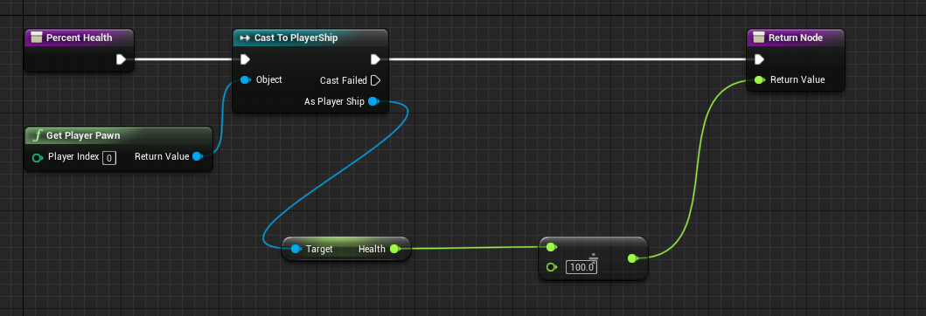

Ammo Bar Percentage in Game Display (implementation in screenshot)

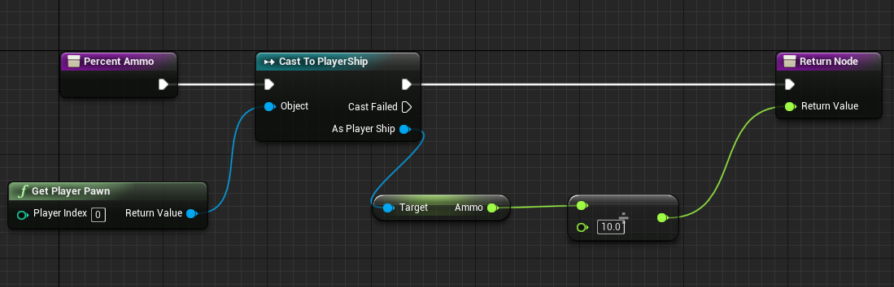

# Game Component & Feature 3:

## DESCRIPTION

Win Condition and scoring system comprised of 4 inputs

1. Candies Hit * 1000
2. Candies Miss * -50
3. Health Left * 50
4. Ammo Left * 20

## REASONING

Aiming for a new high score enables enjoyable replayabilty. A player must choose between ramming a runaway enemy with their body, taking damage that may be replenished later, or hold onto their health but lose the score. Ammo is encouraged to be used, so has a lower score return on hoarding

## BLUEPRINTS AND IMPLEMENTATION

Hit Candies recorded in ShipGameMode from Enemy Ship

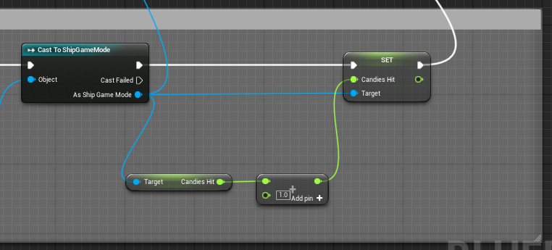

Miss Candies recorded in Ship Game Mode from Enemy Ship

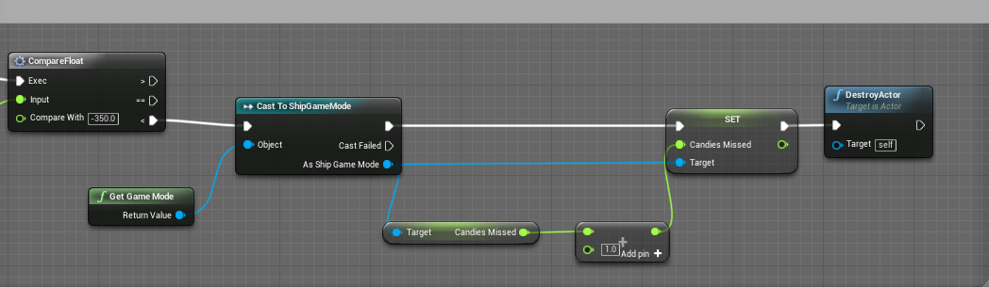

Player Health and Ammo recorded in Ship Game Mode upon from PlayerShip

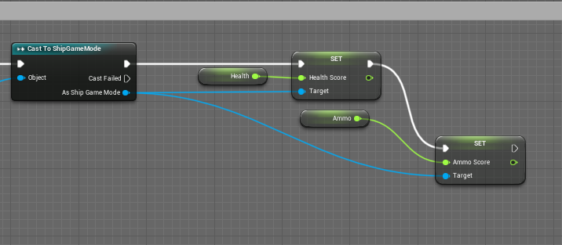

Hit score sourced from EnemyShip upon Win

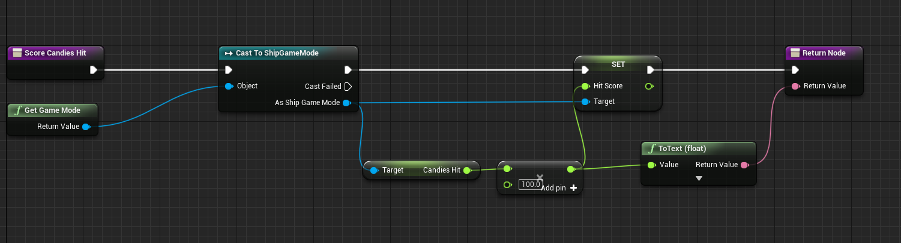

Missed negative score sourced from EnemyShip upon Win

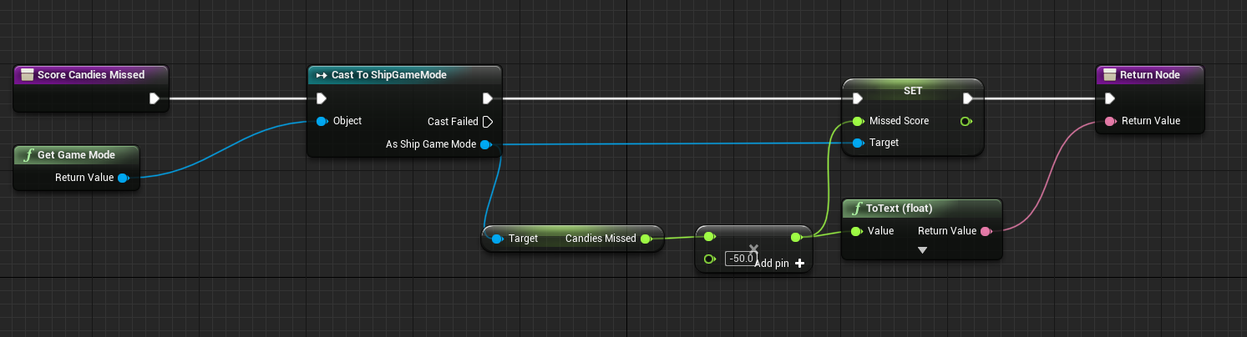

Health score sourced from Playership upon Win

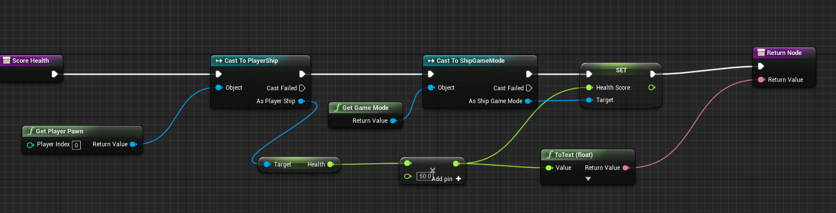

Ammo Score Sourced from PlayerShip upon Win

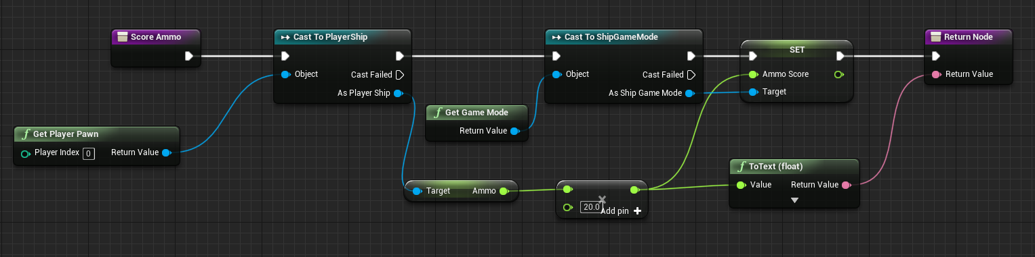

Combination of 4 Values for total score

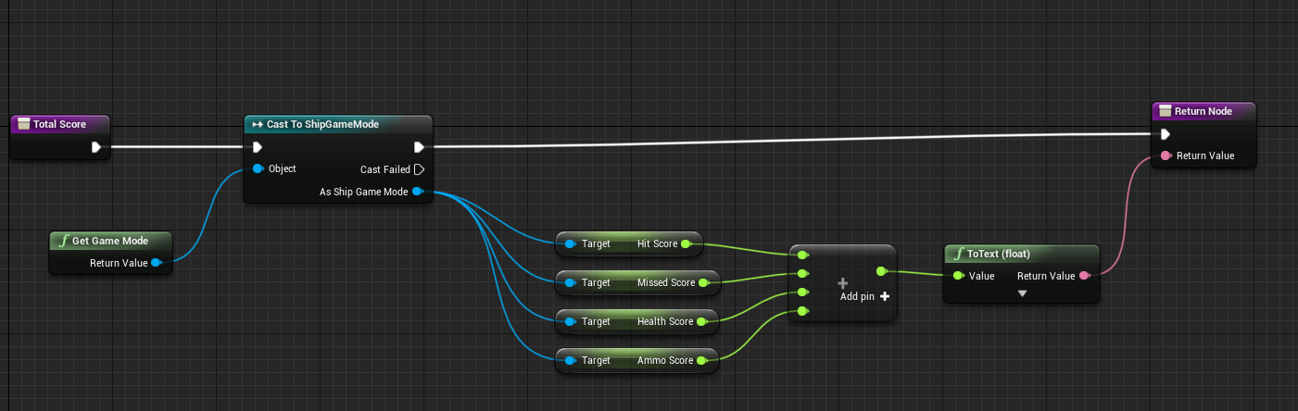

Screenshot of example score

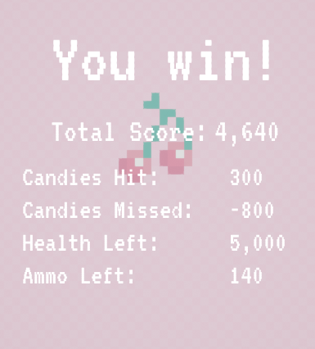

# Game Component & Feature 1:

Dynamic Difficulty Adjustment was included to influence the drop of useful items for example: once the player’s health drops below 50%, the item drops switch to full health refill drops

## REASONING

I included the full health refill to encourage the player when they might start feeling discouraged as their health drops. A level of skill is still required as the drop rate stays the same and the player still must manoeuvre around enemies in attempts to collect the toothpaste to keep the themselves alive.

## BLUEPRINTS AND IMPLEMENTATION

Implementation of item appearing mid game

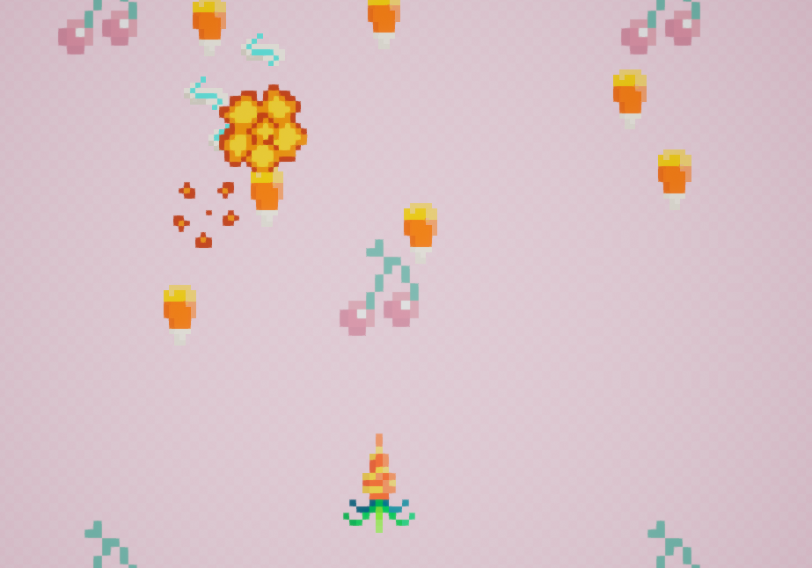

Spawn conditions on EnemyShip Death by Bullet

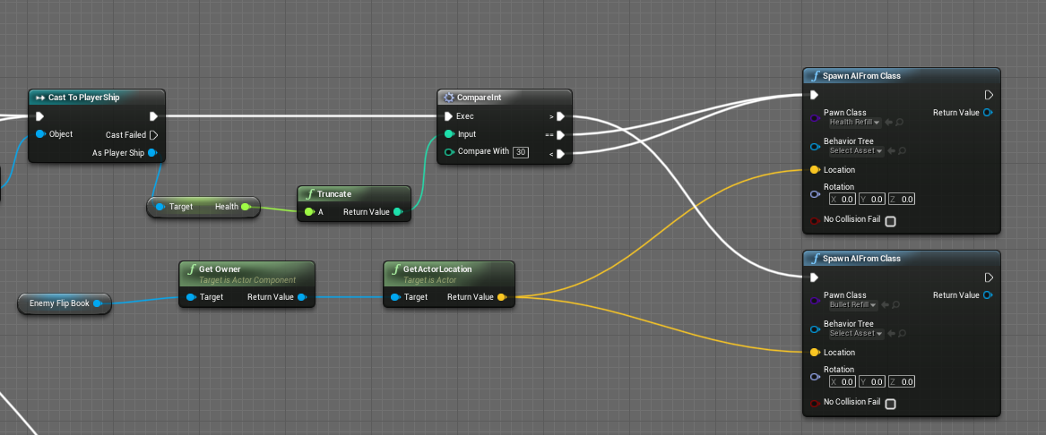

# Extra Transformations or Features

***INCLUDE IF APPLICABLE***

*If you have invested significant effort in improving and enhancing the game beyond your chosen components such as extra features or transformations to the game, include details here. Please note that these must demonstrate effort above and beyond assessment requirements in order to be taken into consideration or bonus marks, and are not a replacement for your required chosen features.*

* Random Location enemy spawner added above, for variation in gameplay each playthrough

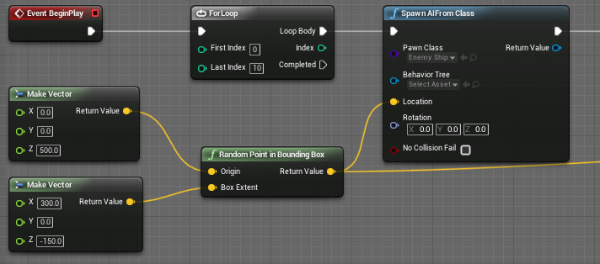

* Two powerups were added to the game:
  + a corn cob which refills a portion of the ammo cache

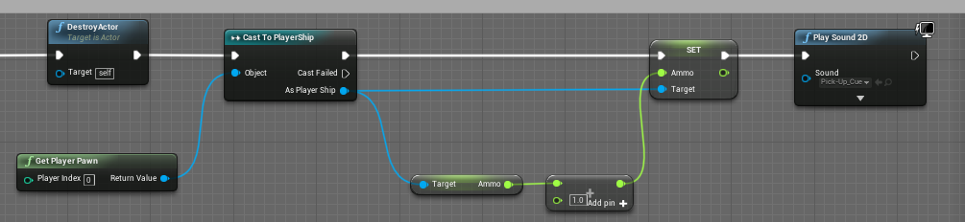

* + a toothpaste swirl which refills the health bar

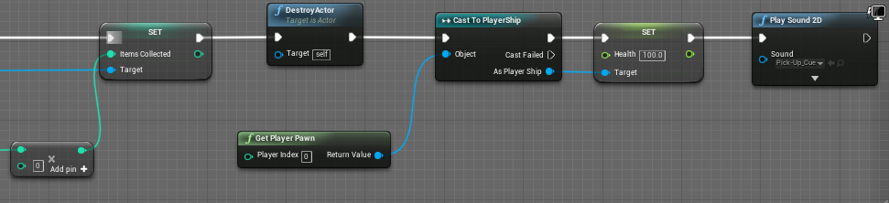

* Added 2nd wave with reduced drop chance

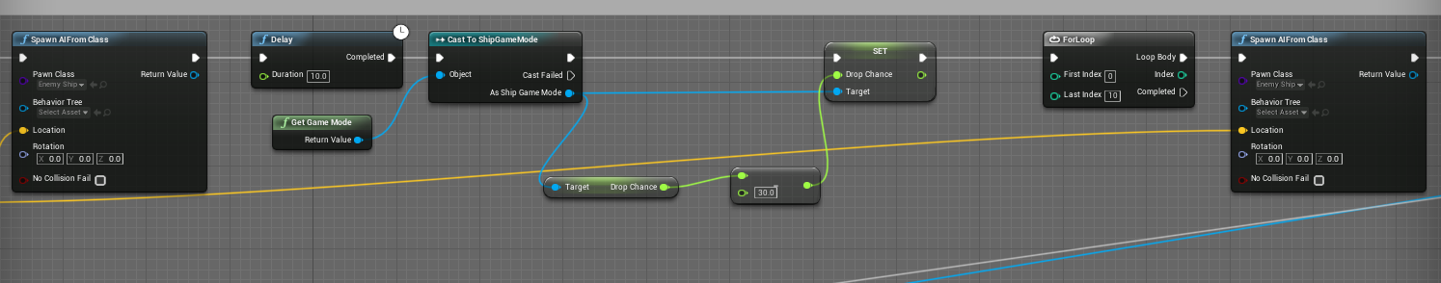

* + Possibility of 3rd with further reduced drop chance
* Intro with instructions

# References

*This should include references to any external tutorials, guides or documentation used, as well as any externally-sourced assets such as images or sounds.*

## **References**

"Beepbox" 2019, retrieved 20 May 2019, <https://beepbox.co/>.

"Changing Fill of a Progress Bar To Image/Gradient Fill - UE4 AnswerHub" 2019, retrieved 24 May 2019, <https://answers.unrealengine.com/questions/589818/changing-fill-image-of-a-progress-bar.html?sort=oldest>.

"GIMP" 2019, retrieved 24 May 2019, <https://www.gimp.org/>.

"How can I run a flip book animation one time then stop? - UE4 AnswerHub" 2019, retrieved 24 May 2019, <https://answers.unrealengine.com/questions/98758/how-can-i-run-a-flip-book-animation-one-time-then.html?sort=oldest>.

"Random Spawn within Boundary" 2019, retrieved 24 May 2019, <https://answers.unrealengine.com/storage/attachments/251583-capture.png>.